Room C
CQ1 Trauma MVC Pancreatic Injury
Stem: In the trauma bay, A 35-Year-old female, involved in a head on MVC. ATLS protocols are followed. You do primary and secondary surveys. IV access ensured, she is talking to you and is complaining of pain primarily in her chest and abdomen.
Vitals: HR of 130, BP 150/90, RR 18 and sating 99% on room air.
She is noted to have a seatbelt sign and. Her chest wall is mildly tender, her abdomen is peritonitic with severe epigastric tenderness.
Medical and Surgical history are unremarkable.
FAST / CXR are negative.
How are you going to manage this patient?
- ATLS
- Trauma panel (Labs are significant for WBC 16.0, Hgb 12.2, CMP is normal, and amylase is 300, lactate 1.0.
- CT scan
CT scan : Shows a small amount of free fluid around the left upper quadrant and lesser sac, as well as a Grade 4 splenic laceration.
What is your differential diagnosis?
- Known splenic injury.
- Pancreatic Injury
- Perforated viscus (small bowel or stomach)
After CT scan, her BP trends down to 80/40, HR 140.
- Transfuse blood products (start with 2 units PRBCs)
- Ex.lap
  - Open / Explore
  - Pack 4 quadrants (Pressure responded to transfusion)
  - Splenectomy
  - Explore
Splenectomy was uncomplicated, hemostasis achieved, patient is hemodynamically stable.
You notice mild contusion of the pancreatic body, you can’t see obvious duct injury? What would you do?
Place Darin
You place a drain and conclude your operation, patient is closed, no packs left. Patient is clinically stable on POD 1 , on POD 2 you notice the drain is putting > 350 cc per day , output looks serosang. Your junior resident is asking you if they can obtain labs from the drain output, would you like to order specific labs?
Amylase from drain: > 2 times upper limit of normal
Next day drain is with higher output, what would you like to do?!
- MRCP with secretin stimulation for evaluation of main pancreatic duct (ERCP is an acceptable alternative, but risk of worsening pancreatitis in trauma patient): MRCP negative.
- Consider octreotide.
- Repeat CT in 4-6 weeks?
What If persistent drainage , now a fistula? ERCP / Stent
What if when obtained MRCP earlier, it showed main pancreatic duct disruption?! ERCP/ Stent
ERCP attempted, Due to the patient’s anatomy, multiple attempts at pancreatic ductal cannulation were unsuccessful and the procedure was aborted. The patient continues to have high output of the LUQ drain despite being on octreotide How would you manage?

Ex lap for distal pancreatectomy.
- Attachments of spleen will already have been mobilized.
- Mobilize Splenic flexure more.
- Open entirety of gastrocolic ligament.
- Mobilize tail of pancreas to confluence of SMV/Splenic vein and transect pancreas.
- Sharp division or division with energy device with oversewing of duct and gland. +/- oversewing.
- Can cover with omentum

Pitfalls:
- Differential diagnosis does not include pancreatic injury or perforated viscus.
- When to transfuse.
- When to Ex.lap for splenectomy.
- Resident not exploring lesser sac to evaluate for pancreatic injury
- Resident Not leaving a drain in the setting of pancreatic contusion.
- Not checking fluid and serum amylase level with high drain output and known pancreatic injury.
- Risk of pancreatitis with ERCp , start with MRCP.
- Recognize the need for distal pancreatectomy and intervention prior to obliterative peritonitis.
References:
- https://www.ncbi.nlm.nih.gov/books/NBK459365/#:~:text=ERCP%2Dguided%20stent%20placement%20or,injury%20in%20blunt%20abdominal%20trauma.

CQ2 HIRSCHSPRUNG’S DISEASE (CONGENITAL AGANGLIONOSIS)
Stem: 3 day old infant born at 38 weeks to a 36 yo mother, presenting with bilious emesis, abdominal distention, and failure to pass meconium or stool since birth.
Anorectal examination shows a normal anus with no abnormalities, distended and tympanic abdomen, and facial abnormalities suggestive of trisomy 21.
Digital rectal exam demonstrates absence of stool in the rectum.

What is your differential diagnosis?

- Hirschsprung’s disease
- Meconium ileus
- Meconium plug syndrome

What would you like to do now?

- Abdominal XR : Dilated bowel throughout
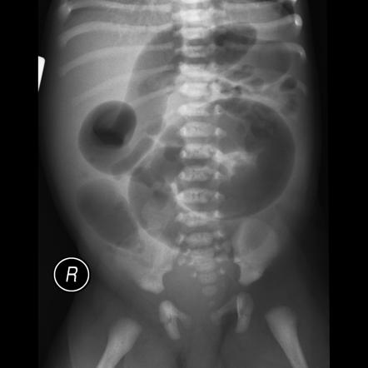

- Barium enema: Transition zone in the mid sigmoid colon.
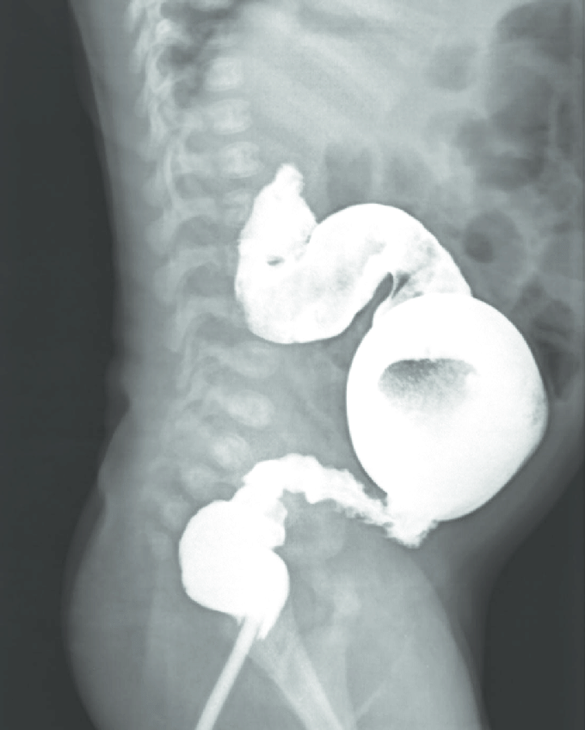

- Rectal suction biopsy: Shows a lack of ganglion cells in the myenteric plexus and hypertrophied nerve roots
- Pre-op work-up:
- Cardiac echo to eval for abnormalities.
- Send home with rectal irrigation instructions.
- Continue enteral feeding.

How to do the rectal suction biopsy? Perform first biopsy 1-2cm above the dentate line, get a second biopsy proximal to this.

When would you offer surgical treatment? Describe.
- Typically done at 9-12mo of age.
- Determine the transition zone with serial seromuscular biopsies sent for frozen section.
- Perform Laparoscopic mobilization of colon and circumferential dissection in the pelvis.
- Abdominoperineal pull-through procedure types:

Swenson: Excision of the aganglionic bowel with end-to-end-anastomosis
  - Transanal full thickness incision of rectum 1cm proximal to dentate line
  - Circumferential dissection along the serosa of the rectum with traction sutures
  - Pull through aganglionic segment.
  - Transect at transition zone.
  - Anastomose to distal rectum in single layer, interrupted sutures.

Soave: Excision of aganglionic bowel with mucosectomy at the bottom of the rectum and pull through of the normal bowel within a cuff of aganglionic muscle
- Submucosal dissection of distal 4cm of rectum (either via abdominal or perineal approach.
- Split the posterior muscular cuff with cautery.
- Incise the muscular cuff 1cm proximal to dentate line.
- Pull through of normal bowel.

Duhamel: Retention of a short segment of aganglionic rectum with posterior pull through of normal bowel and a side-to-side stapled anastomosis.
- Mobilize the rectum and distal colon, divide several cm below the peritoneal reflection.
- Remove aganglionic segment.

Pitfalls: Know timing and types of procedures.

References:
- https://www.sages.org/wiki/hirschsprung-disease-2/
- https://www.facs.org/media/f5obmkmr/07_hirschsprungs_disease.pdf
- https://www.ncbi.nlm.nih.gov/pmc/articles/PMC7318734/

CQ3 Burn
Stem: A 47 y/o male is brought to the ED by EMS after being evacuated from a bedroom fire, started while he was smoking in his bed.
Upon evaluation he is awake and conversive but appears confused.
He is noted to have 60% TBSA burns to his upper torso, sparing only his lower extremities. His nasal hair is singed and he has a productive cough with a hoarse voice.
HR- 115, RR- 30, BP – 95/50, Temp – 37C, SpO2-100%.

Additional Workup or Studies:
CMP, CBC, carboxyhemoglobin, lactate

What are you concerned about?!:
- Airway compromise with an upper airway inhalation injury.
- Decreased pulmonary compliance
- Circumferential burns to the torso
- Carbon monoxide poisoning
- Hypothermia
- ARDS/multisystem organ failure
- Compartment syndrome in extremities or abdomen

What would you like to do now?
- Intubate – 100% FiO2
- Serial carboxyhemoglobin levels
- Establish adequate IV access and initiate fluid resuscitation using parkland formula: (What is the formula?)

2-4 ml/kg/%TBSA burn using LR.
First ½ within 8 hours of burn.
Second ½ in the next 16 hours

- Place a foley to monitor resuscitation. (What is the goal) : Goal 30 – 50 cc/hr

Scenario: Patient is 100 kg, received 60% TBSA burn. He arrives four hours after his burn and has received a total of four liters of crystalloid. How would you manage his fluids at this point?

Parkland: 100 kg * 60% *2ml/kg = 12L in first 24 hours, 6L in first 8 hours. Patient has already received 4L, 500 cc/hr for the remainder of the first 8 hours.

Two hours into resuscitation, UOP drops to 15 ml/hr. How would you proceed?

Increase rate by 30%

What if UOP was > 50 cc per hour?
Decrease rate by 20%

Despite an increase in fluids for two hours, UOP still remains low, now 10 cc/hr. How would you proceed?
- Begin albumin resuscitation: start albumin at 1/3rd current IV rate and decrease IV rate by 1/3rd, total volume unchanged.

Still oliguric at hourly UOP check? Increase albumin by 30%

Scenario: Patient has been transported to the ICU and is being mechanically ventilated. You get a call from respiratory therapy that his peak airway pressures have increased to 35. What are you concerned about?

- Abdominal compartment syndrome.
- Restrictive physiology due to thoracic eschars

What would you do?
- check bladder pressure. (No abdominal compartment)
- Perform escharotomy of thorax.

Describe
- Escharotomy of the thorax
- Vertical incision bilaterally between mid-clavicular line and mid axillary line.
- Connected by transverse incision x 2
- Bronchoscopy to evaluate degree of inhalational injury for prognostication and treat potential mucus plugging.

What is the ARDS/vent management?
- Low tidal volume (4-6 ml/kg)
- Peak pressures <30
- Permissive hypercapnia (ph >7.2)
- Increase PEEP
- Consider proning.

Scenario 3: Patient is going to require skin grafting. How do you medically manage them until that process? What is the nutrition/caloric need?
Enteral nutrition after resuscitation complete
25 kcal/kg +40 kcal/%TBSA, protein 1.5 g/kg +3 g/%TBSA.

Scenario 4: 65 y/o male cement worker presents after cement has spilled through his shirt on his chest and he continued to work in the sun for the next 6 hours but noticed a terrible burning sensation over the area at the end of his shift. HR 90, BP 120/80, RR 15, Temp 37.2, what would you do?

- Call Poison control to obtain further recommendations and verify acid vs alkali
- Determine alkali burn – liquefactive necrosis.
- Begin burn resuscitation.
- Large volume lavage with water until pH <8, may require operative debridement.
- May require skin graft once wound has stabilized.
Pitfalls:
- Calculates Parkland formula correctly.
- Correct algorithm for oliguria Initiates albumin
- resuscitation
- Recognizes risk for ACS and chest compartment syndrome

References:
https://www.ncbi.nlm.nih.gov/books/NBK430741/

